**Practical No. 05**

**Working with Collections**

1. **Index-by tables or Associativ array**
2. **Nested Tables**
3. **VArray or Variable Size Array**

**Name: Sibaraj Lenka**

**Class: FYBScIT(A)**

**Roll No.: 58**

**Subject: PLSQL**

**Sign:**

1. **Index-by tables or Associativ array**

SET SERVEROUTPUT ON;

DECLARE

TYPE salary IS TABLE OF NUMBER INDEX BY VARCHAR2(20);

salary_list salary;

name VARCHAR2(20);

BEGIN

-- adding elements to the table

salary_list('Rajnish') := 62000;

salary_list('Minakshi') := 75000;

salary_list('Martin') := 100000;

salary_list('James') := 78000;

-- printing the table

name := salary_list.FIRST;

WHILE name IS NOT null LOOP

dbms_output.put_line

('Salary of ' || name || ' is ' || TO_CHAR(salary_list(name)));

name := salary_list.NEXT(name);

END LOOP;

END;

/

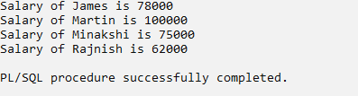

1. **Nested Tables**

SET SERVEROUTPUT ON;

DECLARE

TYPE names_table IS TABLE OF VARCHAR2(10);

TYPE grades IS TABLE OF INTEGER;

names names_table;

marks grades;

total integer;

BEGIN

names := names_table('Kavita', 'Pritam', 'Ayan', 'Rishav', 'Aziz');

marks:= grades(98, 97, 78, 87, 92);

total := names.count;

dbms_output.put_line('Total '|| total || ' Students');

FOR i IN 1 .. total LOOP

dbms_output.put_line('Student:'||names(i)||', Marks:' || marks(i));

end loop;

END;

/

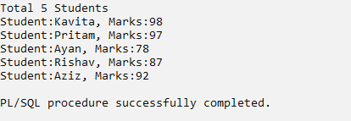

1. **VArray or Variable Size Array**

SET SERVEROUTPUT ON;

DECLARE

TYPE GradeList IS VARRAY(5) OF NUMBER(3, 1);

student_grades GradeList := GradeList(85.5, 90.2, 78.3, 88.0, 92.1);

BEGIN

FOR i IN 1 .. student_grades.COUNT LOOP

DBMS_OUTPUT.PUT_LINE('Grade ' || i || ': ' || student_grades(i));

END LOOP;

END;

/

